PROJECT REPORT

Adidas Shoe Store Mobile Application and Web Administration System

PRM393 • Flutter Mobile Programming
November 2026

Executive Summary
This report presents the design and implementation of an educational shoe-store system with a Flutter customer application, a Node.js and Express API, a MySQL database, and a browser-based administration interface. It supports product discovery, cart and wishlist management, addresses, checkout, order tracking, reviews, notifications, realtime chat, and administration.
The backend uses JWT authentication, role-based authorization, bcrypt password hashing, input validation, parameterized SQL, and transactional inventory updates. Checkout records the purchase-time unit price and rolls back if stock validation fails. VNPay is integrated as a sandbox demonstration: the backend signs payment requests and validates signed callbacks before updating payment state.
The project is organized as a course prototype. It includes seed data, API documentation, a Postman collection, and local run instructions. Production deployment, real payment settlement, and release signing require environment-specific configuration and are outside the verified local build scope.

Report Contents
- 1. Introduction and project scope
- 2. Requirements and system actors
- 3. System architecture and use cases
- 4. Database design
- 5. Order and payment workflow
- 6. Implementation details
- 7. Security and data integrity
- 8. Setup and verification
- 9. Limitations and future work
- 10. Conclusion and project artifacts
- 11. Appendix A. Requirements and detailed design supplement

1. Introduction and Project Scope

1.1 Background
Online footwear shopping requires customers to compare products and variants, confirm stock, choose delivery details, and follow an order through fulfillment. Store staff need tools to maintain the catalog, update order status, answer questions, and review sales and inventory metrics. This project connects those tasks in a mobile-first shopping flow with a separate web administration interface.

1.2 Objectives
- Build a Flutter application that obtains catalog and commerce data from a backend API.
- Implement customer and administrator authentication with role-based access.
- Persist catalog, inventory, carts, orders, payments, reviews, messages, and notifications in MySQL.
- Protect checkout with a database transaction and a locked stock check.
- Provide web tools for catalog, order, user, analytics, and chat operations.
- Demonstrate VNPay payment initiation and callback verification in the sandbox.

1.3 Scope
The customer app includes registration and login, home and product browsing, search and filters, product details, cart, wishlist, checkout, order history and details, profile and addresses, notifications, reviews, and chat. The admin interface supports product, category, variant, and image management; order status changes; user management; statistics; and chat replies.
The implementation uses sample store data and VNPay sandbox. It is a coursework demonstration and does not represent a production retail operation or an official Adidas service.

2. Requirements and System Actors

2.1 Actors
Actor | Responsibilities
Customer | Register and sign in; browse and filter products; manage cart, wishlist, profile and addresses; place and track orders; review eligible purchases; chat with the store.
Administrator | Maintain catalog and stock; upload product images; manage orders and users; view basic statistics; answer customer messages.
VNPay sandbox | Host the payment page and send signed return/IPN parameters to the backend.

2.2 Functional Requirements
Area | Supported behavior
Authentication | Register, login, current-user profile, profile update, password change, JWT validation and role checks.
Catalog | Category list; product search/filter/sort/pagination; detail with images, variants, stock and rating summary.
Commerce | Cart with stock checks; wishlist; address CRUD; COD/VNPay checkout; order history, details and eligible cancellation.
Administration | Product/category/variant/image CRUD; order status; users; revenue, top-product, low-stock and order-status statistics.
Engagement | Delivered-order reviews, notification list/read state and realtime customer-admin chat.
Payment | Signed VNPay URL, return validation, IPN settlement and payment/order status updates.

2.3 Quality Requirements
- Security: hash passwords, keep secrets in environment variables, authenticate protected routes, verify roles and ownership, and avoid exposing hashes or raw gateway payloads.
- Data integrity: use parameterized queries, database constraints, stock validation and transactions for checkout and cancellation.
- Usability: provide loading, error/retry and empty states for data-driven screens; validate user input.
- Maintainability: separate backend routes, controllers, services and models, and Flutter data, state and presentation layers.

3. System Architecture and Use Cases

3.1 Logical Architecture
The Flutter client and browser admin communicate with the Express backend. REST endpoints handle standard requests, while Socket.IO provides realtime chat. The backend separates route handling, validation, controllers, business services and database models. MySQL is the system of record. VNPay is an external sandbox service connected through a signed payment URL and HTTPS callbacks.
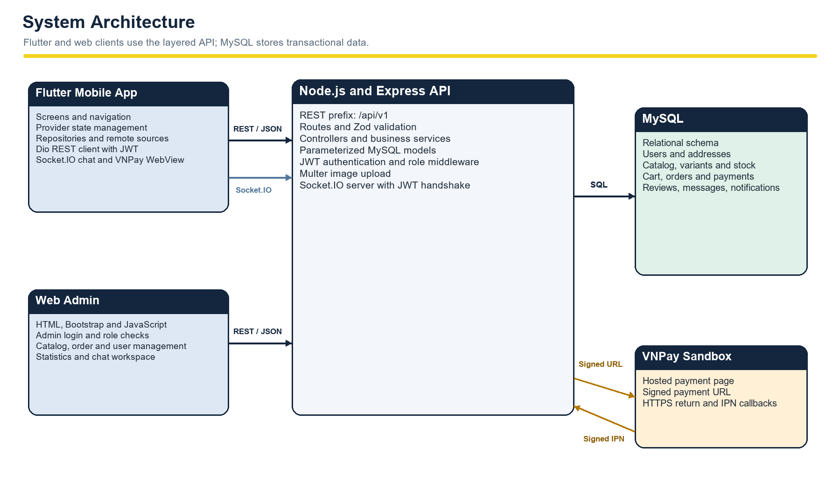
Figure 1. High-level system architecture.
In Flutter, screens use providers for UI state and call repositories backed by remote data sources. Dio attaches the stored JWT to protected requests. The admin is a static HTML, Bootstrap and JavaScript interface served at /admin-ui/.

3.2 Use Case Overview
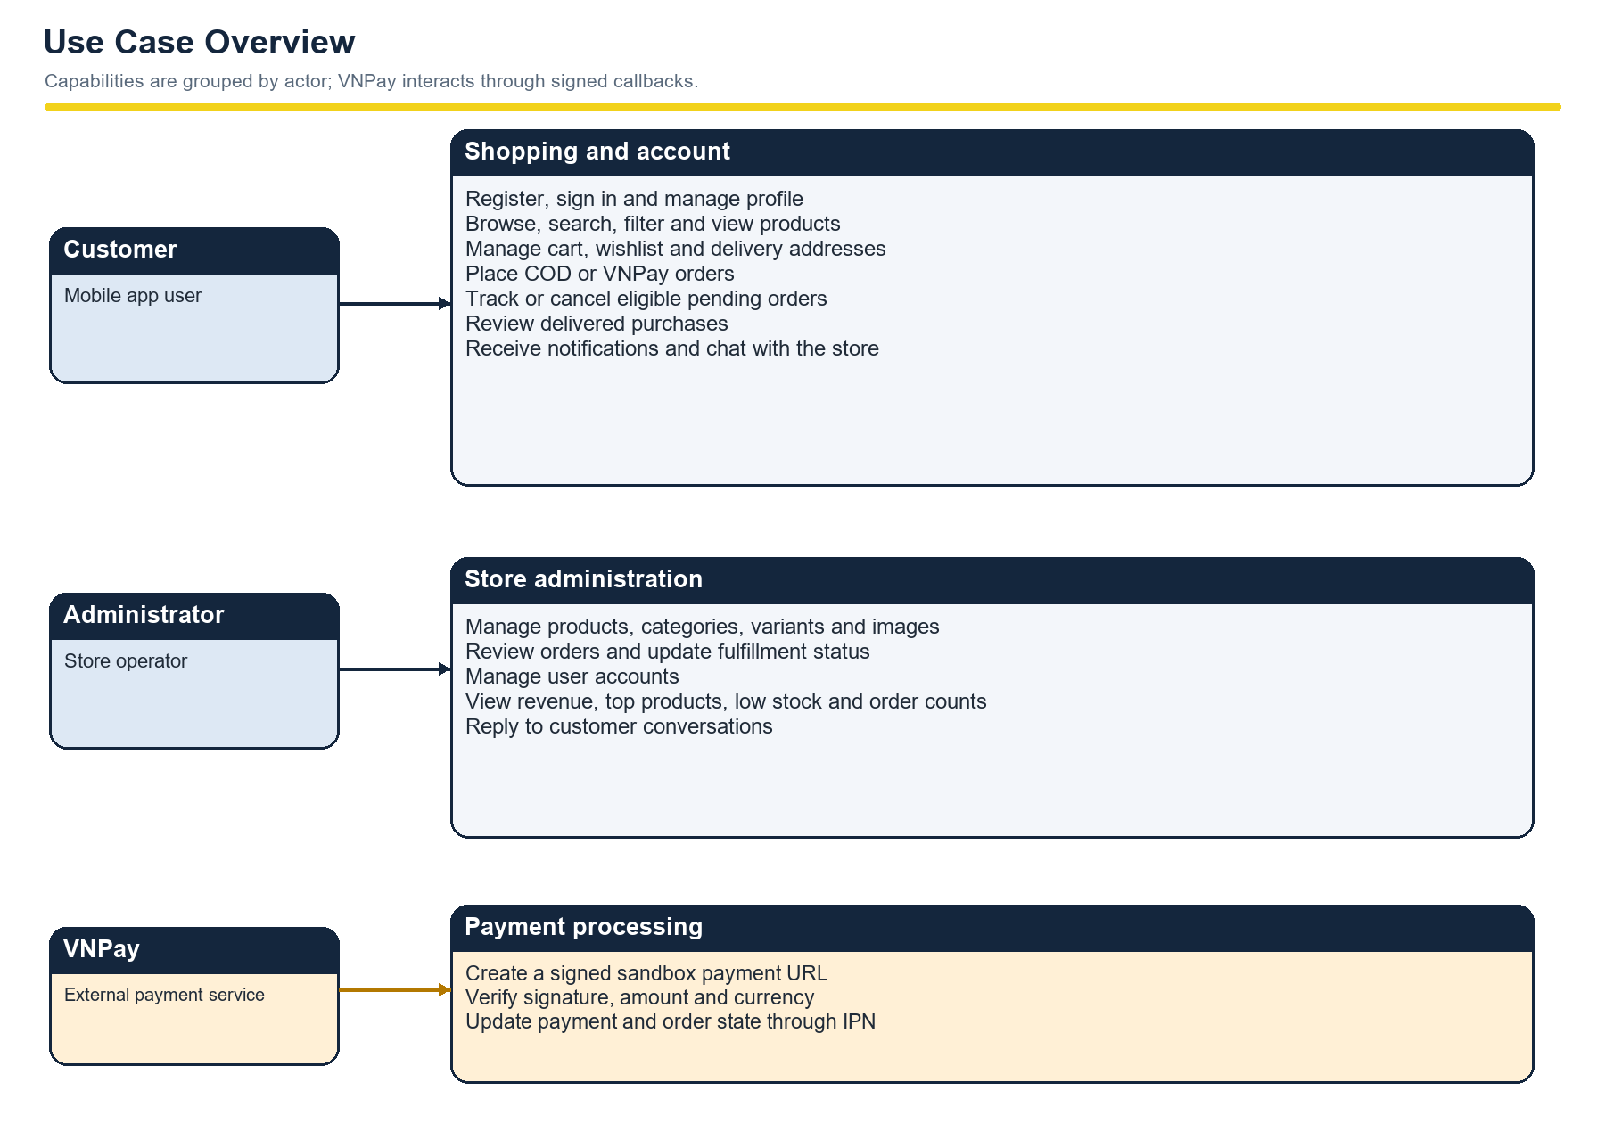
Figure 2. Main customer, administrator and payment-provider use cases.
Role middleware protects administrator routes. Services also check resource ownership, so a customer cannot access another customer’s address, cart, order, review, notification or conversation.

4. Database Design
The MySQL schema contains 15 relational tables grouped into account, catalog, commerce and engagement data. Foreign keys preserve ownership and parent-child relationships. Unique constraints prevent duplicate emails, product variants, cart lines, wishlist entries and user reviews for a product.

4.1 Core Commerce Entities
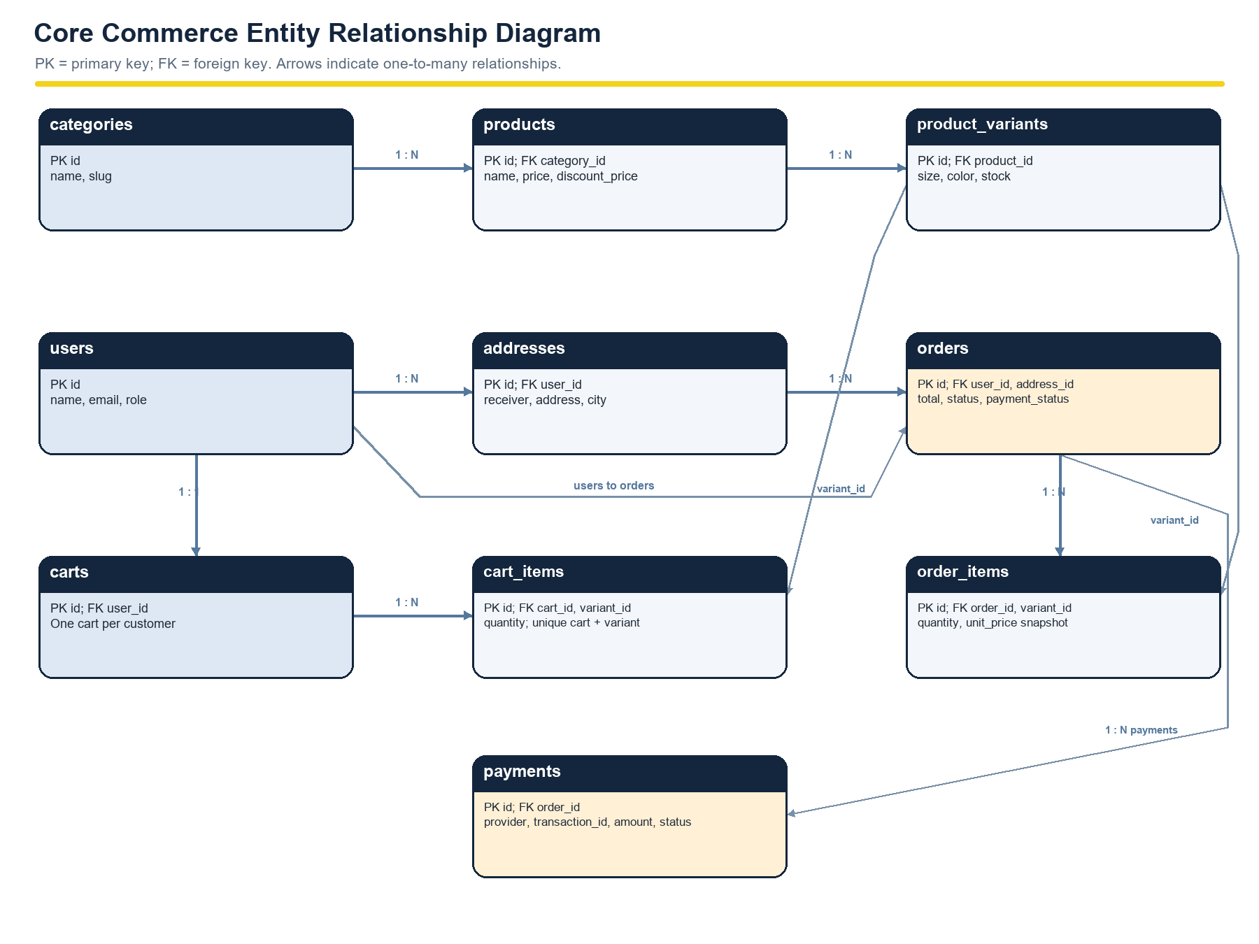
Figure 3. Core commerce ERD: catalog, accounts, carts, orders, line items and payments.
The orders table stores a shipping snapshot so later address edits do not change historical delivery details. Each order_items row records unit_price at purchase time. A cart has a unique owner, and cart_items enforces one row per cart and variant.

4.2 Supporting Entities
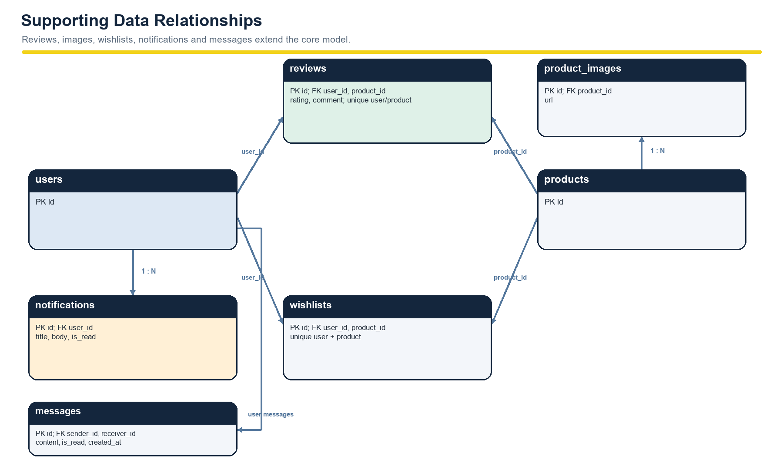
Figure 4. Supporting ERD: product images, reviews, wishlists, notifications and messages.
The reviews table enforces one review per customer and product. The application permits review creation only after a delivered order contains that product. Messages link sender and receiver users; notifications belong to a single user.

4.3 Main Integrity Rules
- A product belongs to a category and may have multiple size/color variants and images.
- A customer owns one cart and may own multiple addresses and orders.
- Cart and order lines refer to variants; order lines preserve their purchase-time price.
- A payment belongs to an order and may have a gateway transaction reference.
- Foreign keys restrict deletion where historical order data must remain valid.

5. Order and Payment Workflow
Checkout starts with an authenticated request containing an address and payment method. The server loads cart contents itself, verifies address ownership, locks the cart and variant rows, checks that each product remains active and sufficiently stocked, and calculates the total from current database prices. It then creates the order and line items, decrements stock, clears the cart and inserts a notification in one transaction.
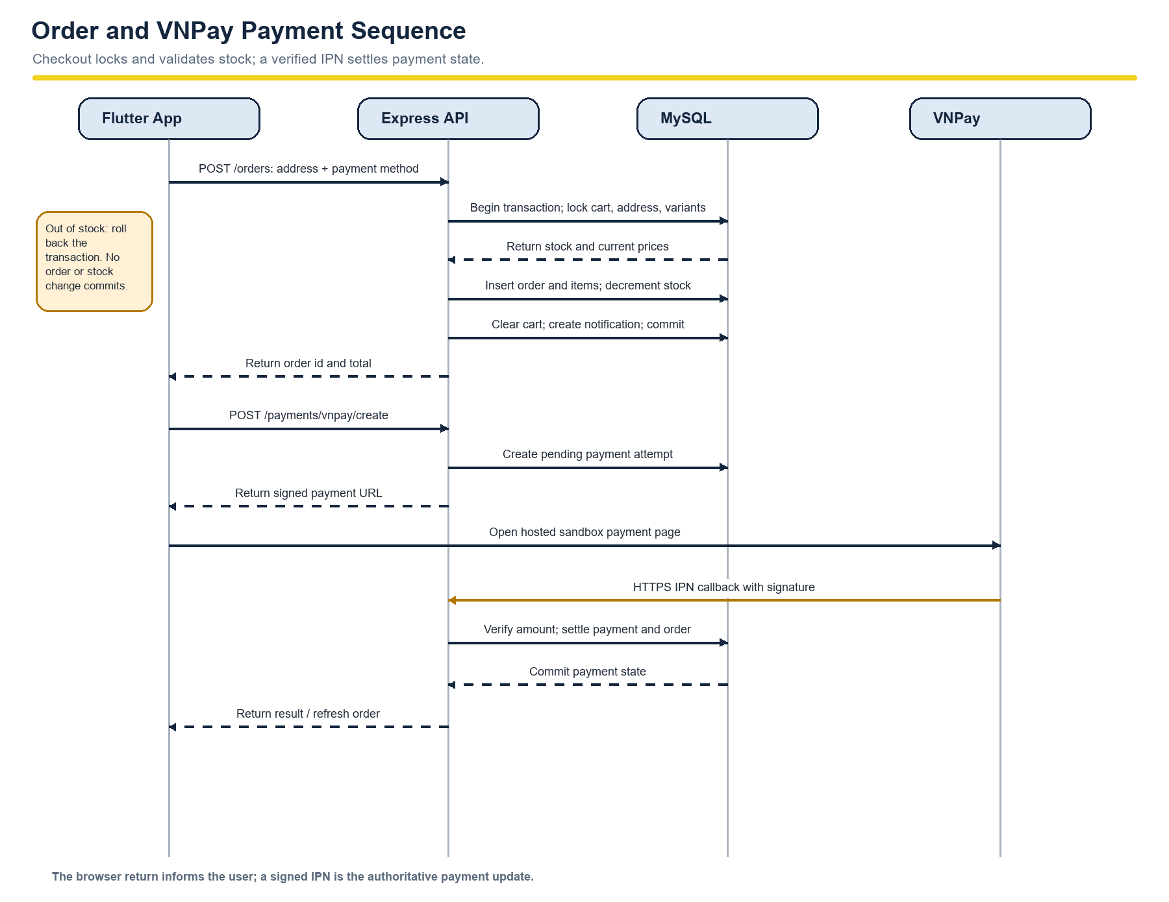
Figure 5. Checkout transaction and VNPay callback sequence.

5.1 Cancellation and Payment State
A customer may cancel an eligible pending order while it remains unpaid or failed. Cancellation locks the order and items, restores quantities, changes the order status and creates a notification in a transaction. VNPay payment attempts have a 15-minute gateway expiry. A valid IPN callback checks the merchant code, signature, transaction reference, amount, currency and payment state before updating the payment and order.
The browser return provides a result for the user interface. The IPN callback is the authoritative server-side payment update; the client-side redirect alone is not proof of payment.

6. Implementation Details

6.1 Backend
The backend is an ES-module Node.js application using Express 5, mysql2, bcryptjs, jsonwebtoken, Zod, Multer, Socket.IO, Helmet, CORS and swagger-ui-express. Routes map to controllers, services and data models. SQL statements use placeholders; user-controlled sort and grouping values are validated against allowlists.
API module | Representative capabilities
Auth | Register, login, current user, profile update and password change.
Catalog | Categories, product search/filter/detail, reviews, admin CRUD and image uploads.
Customer commerce | Cart, wishlist, addresses, orders, cancellation and VNPay creation.
Administration | Orders, users, catalog controls, statistics and chat history.
Realtime and messages | JWT-authenticated Socket.IO conversations, persisted messages and notification routes.
Documentation | Swagger at /api-docs/, OpenAPI JSON at /openapi.json and Postman collection under docs/.

6.2 Flutter Mobile Application
The Flutter app uses Provider for state management, Dio for HTTP, GoRouter for navigation, SharedPreferences for token persistence, webview_flutter for the sandbox payment page, and socket_io_client for realtime chat. The data layer contains models, remote data sources and repositories. Screens cover Home, Search/Product List, Product Detail, Wishlist, Cart, Checkout, Payment, Order List, Order Detail, Profile, Addresses, Notifications and Chat.

6.3 Web Administration
The administrator interface is a static HTML and Bootstrap application with JavaScript. It authenticates an administrator through the backend and exposes catalog CRUD, image uploads, order status management, user management, dashboard charts and a chat workspace.

6.4 Realtime Chat and Notifications
Socket.IO validates the JWT during connection. Customers join their own conversation; administrators join the inbox. The server persists messages before emitting new-message events. Notification records are stored in MySQL and refreshed by the Flutter app through the API.

7. Security and Data Integrity
Control | Implementation purpose
bcrypt password hashing | Avoid storing or returning plaintext passwords.
JWT authentication | Identify signed-in users on protected API and Socket.IO requests.
Role and ownership checks | Limit administrator operations and prevent cross-user access.
Zod validation | Reject malformed request bodies and query parameters at the API boundary.
Parameterized SQL | Keep user values separate from SQL syntax.
Transactional checkout | Lock inventory, validate stock, record price snapshots and roll back on failure.
VNPay signature verification | Validate signed gateway callbacks and check amount and currency.
Upload limits | Restrict product images to supported formats and configured size/count limits.

8. Setup and Verification

8.1 Local Prerequisites
- Node.js and npm for the backend.
- MySQL 8.x or MariaDB 10.5+ for the database.
- Flutter SDK and Android tooling for the mobile application.
- A VNPay sandbox merchant account and public HTTPS URL only when demonstrating callbacks.

8.2 Database and Backend
From the repository root in PowerShell, create the sample database and seed data. The schema script drops and recreates adidas_shop, so preserve any existing database before importing.
mysql -u root -p < schema.sql
mysql -u root -p < seed.sql
Copy-Item BackEnd/.env.example BackEnd/.env
node -e "console.log(require('crypto').randomBytes(48).toString('hex'))"
# Put the generated value and local MySQL values into BackEnd/.env
cd BackEnd
npm install
npm run dev

8.3 Flutter App and Admin
cd FrontEnd
flutter pub get
flutter run --dart-define=API_BASE_URL=http://10.0.2.2:3000/api/v1
Android emulators use 10.0.2.2 to reach the host computer. For a physical phone, configure the computer’s LAN address. The local admin interface is available at http://localhost:3000/admin-ui/. Swagger is available at http://localhost:3000/api-docs/.

8.4 Sample Accounts
Role | Email | Password
Administrator | admin@shop.com | admin123
Customer | user@shop.com | 123456

These are seeded demo accounts. Change or remove them before exposing any environment outside local coursework use.

8.5 Verification Status
The project workspace previously completed Flutter static analysis and a debug APK build. Those checks confirm that Flutter source compiled in the recorded environment; they do not confirm a live MySQL integration, VNPay merchant configuration, public IPN delivery or production deployment.
Verification area | Evidence/status
Flutter static analysis | Previously completed successfully in the project workspace.
Android debug build | Previously completed successfully in the project workspace.
Backend and MySQL integration | Requires local .env and database configuration; run the manual acceptance checks below.
VNPay end-to-end callback | Requires sandbox merchant credentials and a public HTTPS IPN endpoint.
Production release | Signing, deployment secrets, public database/API and device testing remain environment-specific.

8.6 Manual Acceptance Checks
- Attempt checkout above available stock; confirm rejection and unchanged inventory.
- Complete a COD order; confirm order snapshot, stock deduction, cart clearing and notification.
- Cancel an eligible pending unpaid order and confirm inventory is restored once.
- Try to access another customer’s order or address and confirm access is denied.
- Submit a review before and after delivery to confirm the purchase eligibility rule.
- Run a VNPay sandbox payment and confirm only a valid IPN changes stored payment status.

9. Limitations and Future Work
The current implementation is a coursework prototype. A local compile does not establish production readiness; deployment and third-party callback behavior require configuration and runtime verification.
Item | Current state and next step
Payment history detail | GET /payments/:payment_id is listed in the API design but marked as designed rather than implemented.
Review maintenance | Review creation and listing are available; editing and deleting reviews are not implemented.
Unpaid order expiry | VNPay attempts expire after 15 minutes, but abandoned unpaid orders have no automatic job to release reserved stock.
Order retry protection | Add an idempotency key to POST /orders before enabling automatic client retries that could create duplicate orders.
Production operations | Deploy API and database, configure HTTPS/CORS, store secrets securely, monitor errors and test backups.
Release readiness | Set a production Android application ID and configure a signed release build.
Course deliverables | Prepare the final demo video and any required presentation or mockup materials.

Further improvements could include automated API/database integration tests, administrator audit logging, push notifications and a documented refund workflow.

10. Conclusion
The Adidas Shoe Store System demonstrates an end-to-end commerce architecture across Flutter, Express, MySQL and a browser-based admin interface. It connects product discovery to transactional checkout, order tracking, customer support and store administration. Inventory locking, purchase-time price snapshots, authorization checks and signed payment callbacks address key data-integrity and security needs for the prototype.
The next project milestone is to validate the local setup with the supplied database and environment configuration, capture evidence for the acceptance checks, and prepare the release and presentation materials required by the course.

Project Artifacts
Artifact | Purpose
README.md | Project overview, local run instructions, sample accounts and API list.
schema.sql and seed.sql | MySQL schema and sample data.
docs/api-design.md | API contract, endpoint status and workflow notes.
docs/api.postman.json | Postman collection for API requests.
BackEnd/src/docs/openapi.js | OpenAPI specification served through Swagger UI.
BackEnd/.env.example | Template for local backend configuration.
FrontEnd/lib/ | Flutter app, data layer, providers and presentation screens.
admin/ | Static web administration interface.

Appendix A. Requirements and Detailed Design Supplement
This appendix expands the project-specific requirements, workflows, access boundaries, data responsibilities, and detailed design views. The logical deployment view describes the coursework prototype; production hosting and payment callback delivery require environment-specific configuration.

A.1 Coverage Summary
Specification area | Existing report coverage | Supplement in this appendix
System architecture and use cases | Figures 1-2 describe the logical architecture and main actors. | Context diagram, actor catalog, and external interface details.
Core data model | Figures 3-4 show the commerce and supporting ERDs. | Table-by-table purpose, keys, and integrity constraints.
Business workflows | Figure 5 shows transactional checkout and VNPay callbacks. | Order and customer-support swimlanes; structured use-case specifications.
Screens and access control | The Flutter/admin screens are listed in implementation details. | Screen flow, screen catalog, and role/access matrix.
Functional and quality requirements | High-level feature and quality summaries are present. | Traceable functional requirements, quality attributes, interfaces, and known measurement gaps.
Detailed software design | Layered backend/mobile responsibilities are described. | Package, component, deployment, module/class, chat sequence, and order state views.

A.2 System Boundary and External Interfaces
The system boundary includes the Flutter customer client, browser-based administration interface, Express API and Socket.IO server, MySQL database, and local image uploads. The VNPay sandbox remains an external payment service. Users access authenticated shopping features through the mobile application; administrators use the web interface and administrator-protected API routes.
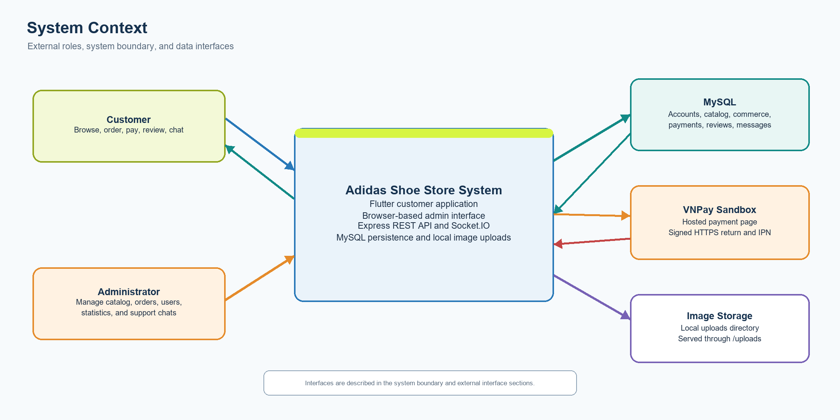
Figure 6. System context and external interfaces.
External interface | Protocol or location | Purpose and boundary
Flutter mobile client | JSON REST over HTTP(S); Socket.IO for chat | Uses Dio for API calls and a JWT bearer token for protected requests. Android emulator development uses 10.0.2.2 to reach the host.
Admin browser | Static HTML/CSS/JavaScript at /admin-ui/ | The Express server serves the admin assets; JavaScript calls the same API and Socket.IO server.
MySQL database | mysql2 connection pool | Stores normalized account, catalog, commerce, payment, and engagement records. SQL uses bound parameters.
VNPay sandbox | Signed HTTPS payment URL, browser return, IPN | The server signs payment requests and validates callback signatures, transaction reference, amount, and currency.
Product image files | Multer uploads in BackEnd/uploads; Express /uploads | Uploaded files are stored locally and served as static product media; a production object-storage service is not configured.

A.3 Actors and Use-Case Catalog
The Customer and Administrator interact through different client surfaces. VNPay is a secondary external actor that participates only in the sandbox payment flow.
ID | Primary actor | Use case | Outcome or main rule
UC-AUTH-01 | Customer / Administrator | Register or sign in | Receive a JWT session; public user registration creates a customer account.
UC-CAT-01 | Customer | Browse and search products | Filter by query, category, price, size, color, sorting, and pagination.
UC-CART-01 | Customer | Manage cart and wishlist | Maintain selected product variants and quantities; validate available stock.
UC-ORD-01 | Customer | Place an order | Create a pending order using the selected owned address and current price.
UC-PAY-01 | Customer / VNPay | Pay with VNPay sandbox | Create a signed payment attempt; IPN is the authoritative settlement callback.
UC-ORD-02 | Customer | Cancel an eligible order | Cancel a pending unpaid or failed order and restore reserved stock once.
UC-ORD-03 | Customer | View order history and details | Read only the signed-in user's order records.
UC-REV-01 | Customer | Review a purchased product | Create one review after an order containing the product is delivered.
UC-CHAT-01 | Customer / Administrator | Exchange support messages | Join the authorized customer conversation and send persisted messages.
UC-ADM-01 | Administrator | Manage catalog and stock | Maintain categories, products, variants, and product images.
UC-ADM-02 | Administrator | Process orders | Apply only supported status transitions and notify the customer.
UC-ADM-03 | Administrator | Manage users and review store metrics | Maintain customer accounts and view revenue, top products, low stock, and order counts.

A.4 Main Workflows and Use-Case Specifications
Checkout and customer support are the two main cross-component workflows. Figure 5 already details the checkout request, stock locking, rollback, and VNPay callback path; Figures 7-8 present the same project behavior as role-based swimlanes.
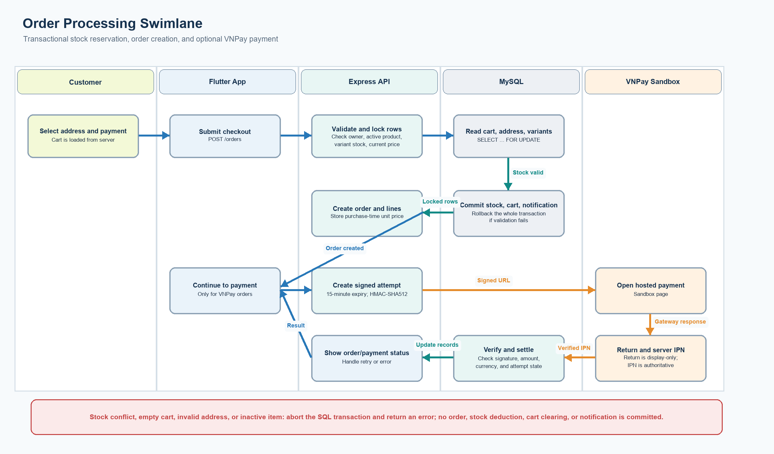
Figure 7. Order processing swimlane with stock-conflict rollback and optional VNPay payment.
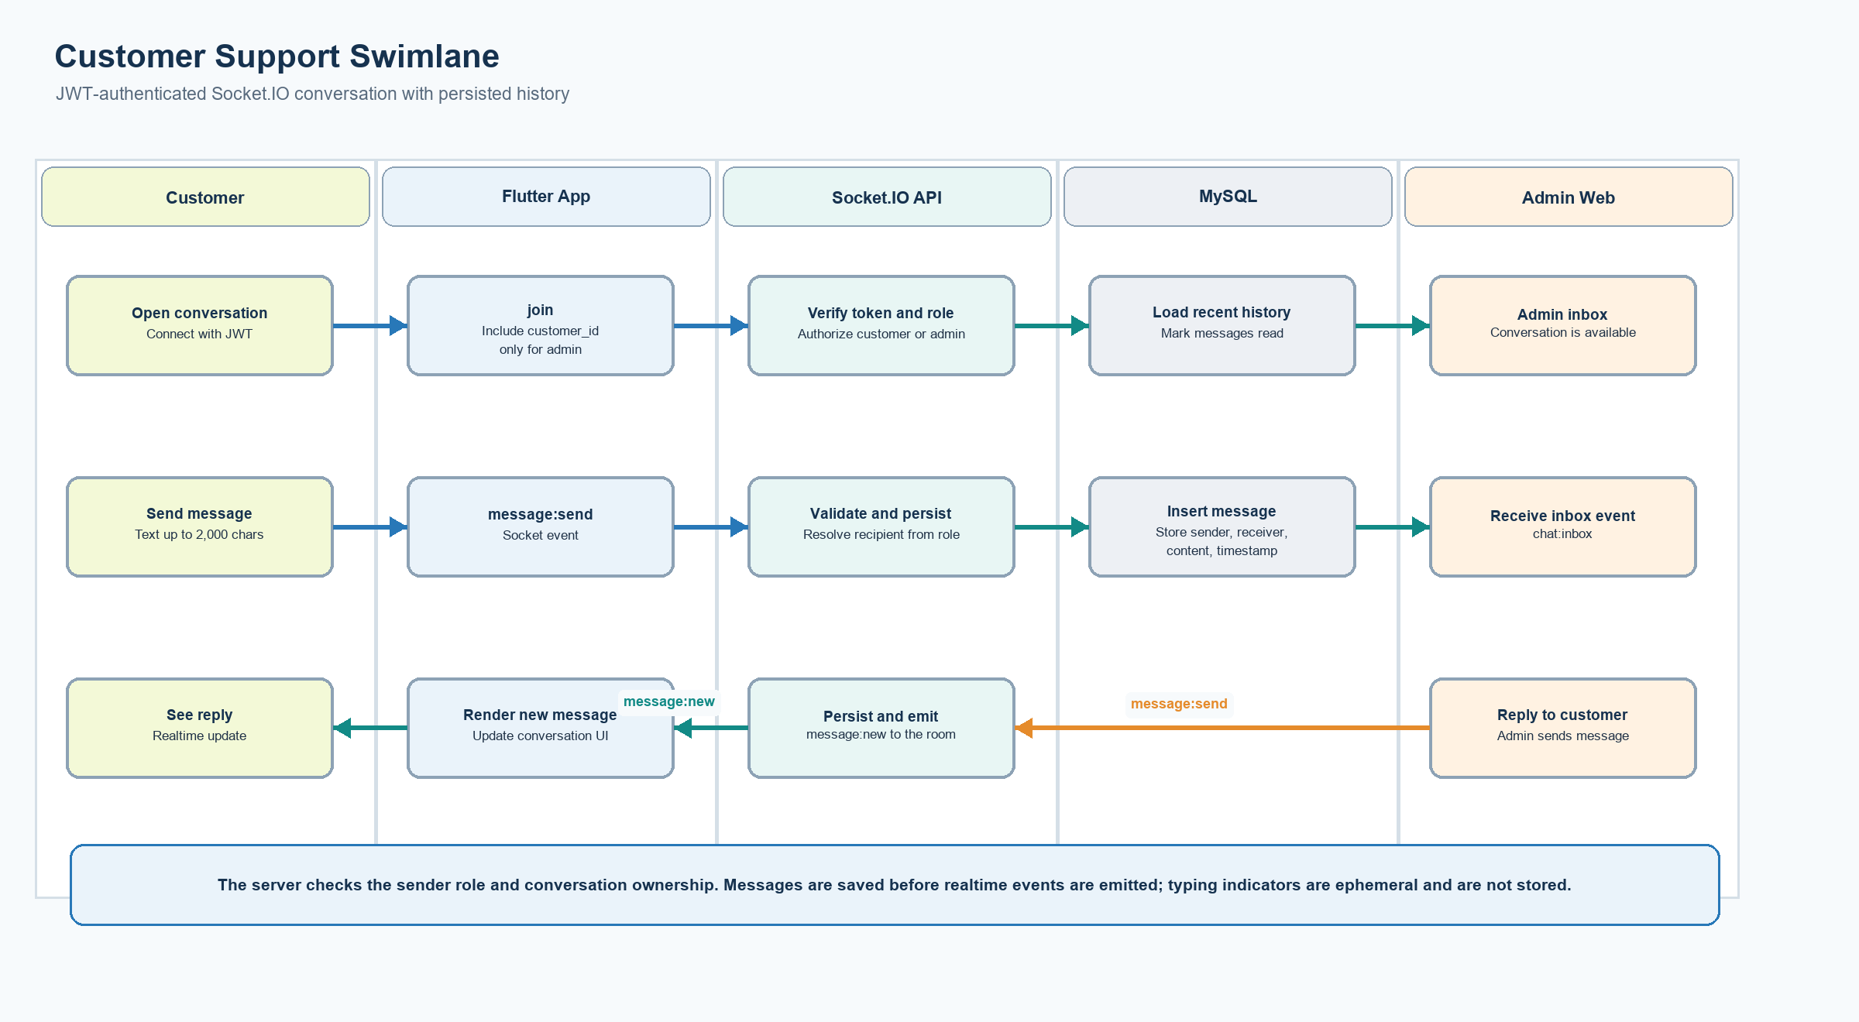
Figure 8. Customer-support chat swimlane.

UC-ORD-01 Place an Order
Specification item | Project behavior
Primary actor | Signed-in customer.
Preconditions | The cart contains at least one item. The selected address belongs to the customer. Each selected variant exists, its product is active, and stock is sufficient.
Successful postcondition | A pending order and purchase-time line prices are committed; stock is decremented; the cart is cleared; and a customer notification is created.
Normal flow | 1. The customer selects a saved address and COD or VNPay. 2. The app submits address_id and payment_method to POST /api/v1/orders. 3. The service loads the customer's cart and locks cart and variant rows. 4. It validates address ownership, active products, stock, and current prices. 5. It creates the order and order items, decrements inventory, clears the cart, and adds a notification in one transaction. 6. For VNPay, the app then requests a signed payment URL.
Alternative and error flows | An empty cart, invalid address, inactive product, insufficient stock, or changed stock returns an error. The transaction rolls back so no partial order, line, stock, cart, or notification changes remain.

UC-PAY-01 Settle a VNPay Sandbox Payment
Specification item | Project behavior
Primary actor | Signed-in customer and VNPay sandbox.
Preconditions | A pending order uses payment_method=vnpay and the sandbox merchant configuration is valid.
Successful postcondition | A verified IPN updates the payment attempt and the related order payment status.
Normal flow | 1. The customer requests payment creation for the order. 2. The backend creates a pending payment attempt with a 15-minute expiry and signs the VNPay parameters with HMAC SHA-512. 3. The app opens the returned URL in a WebView. 4. VNPay sends a browser return and an IPN callback. 5. The backend verifies merchant code, signature, reference, amount, currency, and attempt state before settlement.
Alternative and error flows | Invalid configuration is rejected before URL creation. Invalid callback signatures or amounts are rejected. The browser return is for display; it does not by itself settle the order. Duplicate terminal IPNs are handled idempotently. Abandoned unpaid orders are not automatically expired by a background job.

UC-ORD-02 Cancel an Order
Specification item | Project behavior
Primary actor | Signed-in customer, or administrator through the admin interface.
Preconditions | The order exists, has not been delivered or cancelled, and its payment status is unpaid or failed. A customer can cancel only their own pending order.
Successful postcondition | The order is marked cancelled, item quantities are returned to stock, and the customer is notified.
Normal flow | 1. The requesting actor selects cancel. 2. The server locks the order and its item and variant rows. 3. It checks ownership or administrator authority and verifies the order/payment state. 4. It increments variant stock and updates the order status in one transaction. 5. It creates a notification.
Alternative and error flows | A paid order must be refunded before cancellation, but automated refunds are not implemented. Invalid or repeated transitions are rejected. Any transaction error rolls back the inventory and status changes.

UC-ADM-02 Update Order Status
Specification item | Project behavior
Primary actor | Administrator.
Preconditions | The administrator is authenticated and the requested order exists.
Successful postcondition | The order has a valid next status and the customer receives a notification.
Normal flow | 1. The administrator opens the order list. 2. The admin client sends a status update. 3. The API checks the administrator role and locks the order. 4. The service allows pending to confirmed or cancelled, confirmed to shipping or cancelled, and shipping to delivered. 5. For eligible cancellation it restores stock; for unpaid COD delivered orders it also marks payment paid. 6. The service writes a notification.
Alternative and error flows | Unsupported transitions return a conflict response. Cancellation of a paid order is rejected until a refund is handled.

A.5 Mobile Screens and Access Control
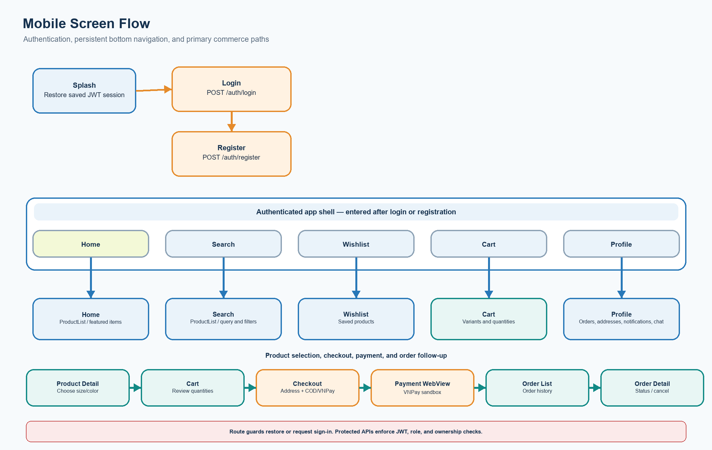
Figure 9. Mobile screen navigation and protected flows.
Screen or route | Actor | Main function and associated use cases
/ and /login | Guest / signed-in user | Restore the saved session or authenticate; UC-AUTH-01.
/register | Guest | Create a customer account; UC-AUTH-01.
/home | Customer | Show catalog entry points and featured products; UC-CAT-01.
/search | Customer | Search, filter, sort, and paginate products; UC-CAT-01.
/products/:id | Customer | View images, variants, stock, rating summary, and reviews; UC-CAT-01 / UC-REV-01.
/wishlist and /cart | Customer | Maintain saved products and variant quantities; UC-CART-01.
/checkout | Customer | Choose address and payment method; create order; UC-ORD-01.
/payments/vnpay | Customer | Open the signed sandbox payment URL and show return outcome; UC-PAY-01.
/orders and /orders/:id | Customer | Read order history/details and cancel an eligible order; UC-ORD-02 / UC-ORD-03.
/profile and /addresses | Customer | Edit profile, password, and delivery addresses.
/notifications | Customer | Read notification records and mark them read.
/chat | Customer | Join the customer's support conversation; UC-CHAT-01.
/admin-ui/ | Administrator | Manage catalog, orders, users, dashboard metrics, and support chats; UC-ADM-01/02/03 and UC-CHAT-01.

Surface | Guest | Customer | Administrator | Enforcement boundary
Login and registration | Allowed | Session-aware | Use admin web login | Public auth endpoints; registration assigns the customer role.
Flutter shopping screens | Redirected to login | Intended client role | No separate Flutter role gate | GoRouter requires sign-in; API JWT and ownership checks protect customer data.
Customer-owned API data | Denied | Own cart, addresses, orders, reviews, notifications, and chat | No customer ownership bypass | Authenticated routes and service-level ownership checks.
Admin UI functions and /api/v1/admin/* | Denied | Denied | Allowed | Backend auth middleware and requireRole('admin').
VNPay return and IPN | Not a user session | N/A | N/A | Callback signature, merchant, reference, amount, and currency checks.
Swagger and OpenAPI | Readable | Readable | Readable | Documentation routes are served by Express; protected endpoints still require authentication.

The mobile router checks whether a session exists but does not add a separate admin-role screen gate. API role checks remain authoritative for administrator endpoints, while ownership checks protect user-specific data.

A.6 Functional Requirements, Services, and Interfaces
ID | Requirement | Primary actor | Acceptance behavior
FR-01 | Authenticate and manage a profile | Customer / Administrator | Register, sign in, restore session, update profile, change password, and sign out; never expose password_hash.
FR-02 | Search the catalog | Customer | Support q, category, minPrice, maxPrice, size, color, sort, page, and limit; return product detail with variants and images.
FR-03 | Maintain cart and wishlist | Customer | Add/remove items and update quantity; enforce one cart line per variant and reject unavailable stock.
FR-04 | Manage delivery addresses | Customer | Create, read, update, and delete the current user's addresses; select an owned address for checkout.
FR-05 | Place and cancel orders safely | Customer | Use transactions and row locks for checkout; capture purchase-time unit price; restore stock only for eligible cancellation.
FR-06 | Support VNPay sandbox | Customer / VNPay | Generate signed URL; verify return and IPN signatures; only verified IPN updates settlement.
FR-07 | Review eligible purchases | Customer | Allow one product review after a delivered order contains that product.
FR-08 | Notify and support customers | Customer / Administrator | List and mark notifications read; persist chat messages and deliver realtime events.
FR-09 | Manage store operations | Administrator | Manage categories, products, variants, images, orders, users, statistics, and chat inbox.
FR-10 | Document and inspect APIs | Developer / Administrator | Serve Swagger UI, OpenAPI JSON, and a Postman collection.

Non-UI Functions
Function | Trigger or interface | Behavior and protection
JWT authentication and validation | POST /auth/register, POST /auth/login; auth middleware | Hash passwords with bcryptjs, issue JWTs, validate claims, and omit password hashes from public user payloads.
Request validation | Zod validators at API boundary | Validate body and query values before business services execute.
Transactional checkout/cancellation | POST /orders; PUT /orders/:id/cancel; admin status update | Lock relevant rows, validate stock/payment state, write changes atomically, and roll back on errors.
VNPay payment creation and callbacks | POST /payments/vnpay/create; GET return; GET IPN | Sign outgoing parameters, validate callback signatures and payment fields, and update payment/order state from IPN.
Image upload and delivery | Admin product image upload; static /uploads | Multer checks file constraints, stores images locally, and Express serves them as static files.
Realtime chat | Socket.IO connect, join, message:send, typing, message:new, chat:inbox | Verify JWT at handshake, authorize conversation membership, persist messages, and emit conversation events.
Notification polling and read state | GET /notifications; PATCH /notifications/:id/read | Return notifications for the authenticated user and update that user's read state.
Administrative metrics | GET /admin/stats/revenue, top-products, low-stock, orders-by-status | Aggregate revenue, product sales, stock, and order status counts for administrators.
API documentation | /api-docs/ and /openapi.json | Expose the OpenAPI specification and interactive Swagger UI.

The codebase does not define a scheduled cleanup job or background worker. In particular, abandoned unpaid orders do not release reserved inventory automatically.

A.7 External Interfaces and Quality Attributes
Attribute | Project requirement and implementation evidence | Verification status
Security | JWT-protected API, administrator role checks, service ownership checks, bcrypt password hashes, Zod validation, Helmet, and environment-based secrets. | Implemented in source; deployment security review remains outstanding.
Data integrity | Foreign keys and unique/check constraints; parameterized SQL; transactional checkout and cancellation with row locks. | Implemented in source; live database integration should be verified in the configured environment.
Usability | Data screens provide loading, empty, and error/retry behavior; forms validate user input; search supports debounce and pagination. | Implemented across the mobile prototype; device usability review is not recorded.
Performance | Catalog and order APIs support bounded pagination; product search is debounced in the client. | No response-time, throughput, or concurrency target and no load-test evidence are specified.
Maintainability | Backend separates routes, controllers, validators, services, models, and utilities; Flutter separates presentation, providers, repositories, data sources, and core networking. | Structure is present in the repository.
Availability and recovery | Local MySQL and single API process are used by the course setup. | No high-availability, backup, disaster-recovery, or monitoring plan is configured.
Interoperability | Flutter and admin use the versioned JSON API; chat uses Socket.IO; VNPay sandbox uses signed HTTPS callbacks. | API docs and local integrations are included; public callback delivery depends on merchant setup.

Quantitative service-level targets are not defined in the project artifacts and are not reported as verified results. They should be agreed and load-tested before production deployment.

A.8 Business Rules and Example System Messages
Rule ID | Project business rule
BR-01 | Public registration creates a customer role; administrator privileges are assigned only through administrator account data.
BR-02 | Each user has at most one cart; a cart has at most one row for each product variant; quantities must be positive.
BR-03 | Only active products with a real variant and sufficient current stock can be ordered.
BR-04 | The checkout price is discount_price when present; otherwise price. order_items.unit_price preserves the price at purchase.
BR-05 | Order creation writes the order, line items, inventory decrement, cart clear, and customer notification atomically.
BR-06 | Customer cancellation is allowed only for the customer's pending order when payment is unpaid or failed.
BR-07 | Administrator transitions are pending to confirmed/cancelled, confirmed to shipping/cancelled, and shipping to delivered.
BR-08 | Cancellation of an unpaid/failed order restores each line quantity to its variant stock; a paid order requires refund handling first.
BR-09 | Delivering an unpaid COD order marks payment paid. VNPay settlement is based on a verified IPN, not solely on browser return.
BR-10 | A customer may create one review per product only after a delivered order containing the product.
BR-11 | A VNPay payment attempt expires after 15 minutes; callbacks must match the merchant code, signature, transaction, amount, and VND currency.

Example context | User-facing meaning | Handling
Invalid form input | Please review the required fields and entered values. | The client displays field validation; the API rejects invalid input.
Invalid sign-in | The email or password is incorrect. | Return an authentication error without exposing credential details.
Insufficient stock | The selected size/color has only N units remaining. | Reject checkout; roll back transaction changes.
Empty cart | Your cart is empty. | Do not create an order.
Unavailable product | A product in the cart is no longer available. | Reject checkout and preserve cart/inventory state.
VNPay configuration or signature failure | Sandbox payment is unavailable or the callback cannot be verified. | Return a service/validation error; do not mark payment successful.
Invalid order transition | This order cannot move to the requested status. | Return a conflict and keep current status.

The messages above summarize project behavior in English for this report. Runtime strings in the current application are primarily Vietnamese.

A.9 Database Table Catalog
The schema uses InnoDB tables and foreign-key relationships. The table below summarizes the implementation in schema.sql; the ERDs in Figures 3-4 remain the relationship diagrams.
Table | Purpose | Primary / foreign / unique constraints
users | Customer and administrator accounts. | PK id; UQ email; role enum customer/admin.
addresses | User-owned delivery addresses. | PK id; FK user_id -> users.id.
categories | Product category definitions. | PK id; UQ slug.
products | Catalog products and price/visibility data. | PK id; FK category_id; nonnegative price; discount not above price.
product_images | Additional product image URLs. | PK id; FK product_id -> products.id.
product_variants | Size/color inventory. | PK id; FK product_id; UQ product_id + size + color.
carts | One shopping cart per user. | PK id; FK user_id; UQ user_id.
cart_items | Cart variant quantities. | PK id; FK cart_id and variant_id; UQ cart_id + variant_id; quantity > 0.
wishlists | Saved products for each user. | PK id; FK user_id and product_id; UQ user_id + product_id.
orders | Order state, shipping snapshot, total, and payment state. | PK id; FK user_id and nullable address_id; total >= 0.
order_items | Variant, quantity, and purchase-time unit price. | PK id; FK order_id and variant_id; quantity > 0.
payments | Payment attempts and provider responses. | PK id; FK order_id; UQ provider + transaction_id.
reviews | Customer product ratings and comments. | PK id; FK product_id and user_id; UQ user_id + product_id; rating 1-5.
messages | Persisted customer/admin chat messages. | PK id; FK sender_id and receiver_id -> users.id.
notifications | User-owned order/system notifications. | PK id; FK user_id -> users.id.

A.10 Detailed Software Structure
The package view follows the repository folders. The component view shows runtime responsibilities and interfaces; these diagrams describe the existing code organization rather than a future microservice architecture.
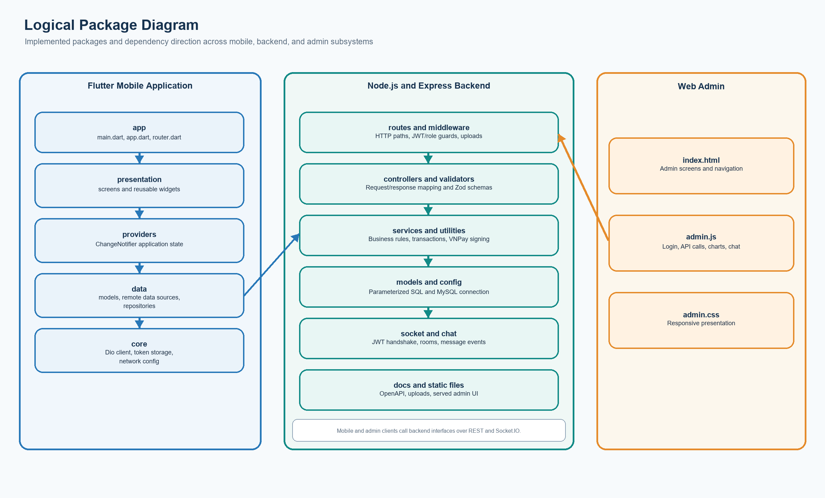
Figure 10. Logical package diagram for Flutter, backend, and web administration.
Subsystem/package | Responsibilities | Representative contents
Flutter app | Application startup, theme, navigation, and dependency wiring. | lib/app, lib/main.dart
Flutter presentation | Screens and shared visual components. | lib/presentation/screens, lib/presentation/widgets
Flutter providers | Auth, product, cart, wishlist, notification, and chat state. | lib/providers
Flutter data | API data sources, domain models, and repository interfaces. | lib/data/datasources, lib/data/models, lib/data/repositories
Flutter core | HTTP configuration, token storage, API errors. | lib/core
Backend boundary | HTTP routes, auth/role middleware, validation, and upload middleware. | src/routes, src/middlewares, src/validators
Backend application | Business operations and transaction coordination. | src/controllers, src/services, src/utils
Backend persistence/integration | Parameterized SQL, MySQL connection, Socket.IO, VNPay signing, OpenAPI. | src/models, src/config, src/socket, src/docs

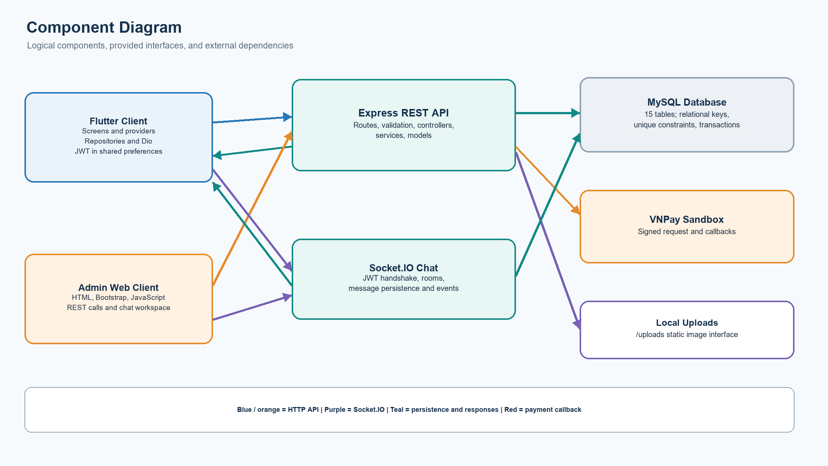
Figure 11. UML-style component diagram and key interfaces.
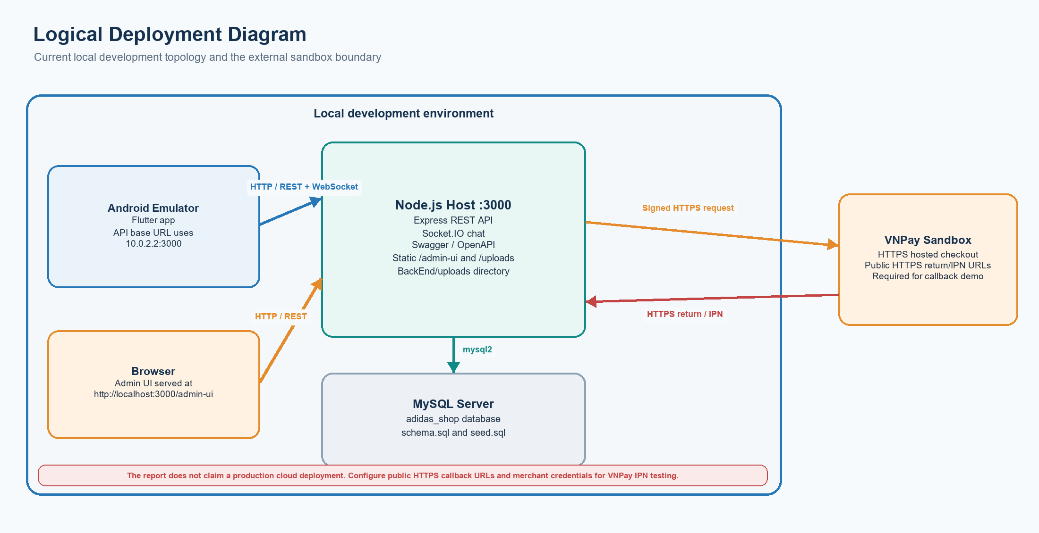
Figure 12. Logical deployment view for the local prototype and VNPay sandbox.

A.11 Detailed Design, Patterns, and State
The backend is implemented with JavaScript ES modules rather than instantiated domain classes. Figure 13 therefore presents a class-style module responsibility view and names the actual modules and operations involved in order creation.
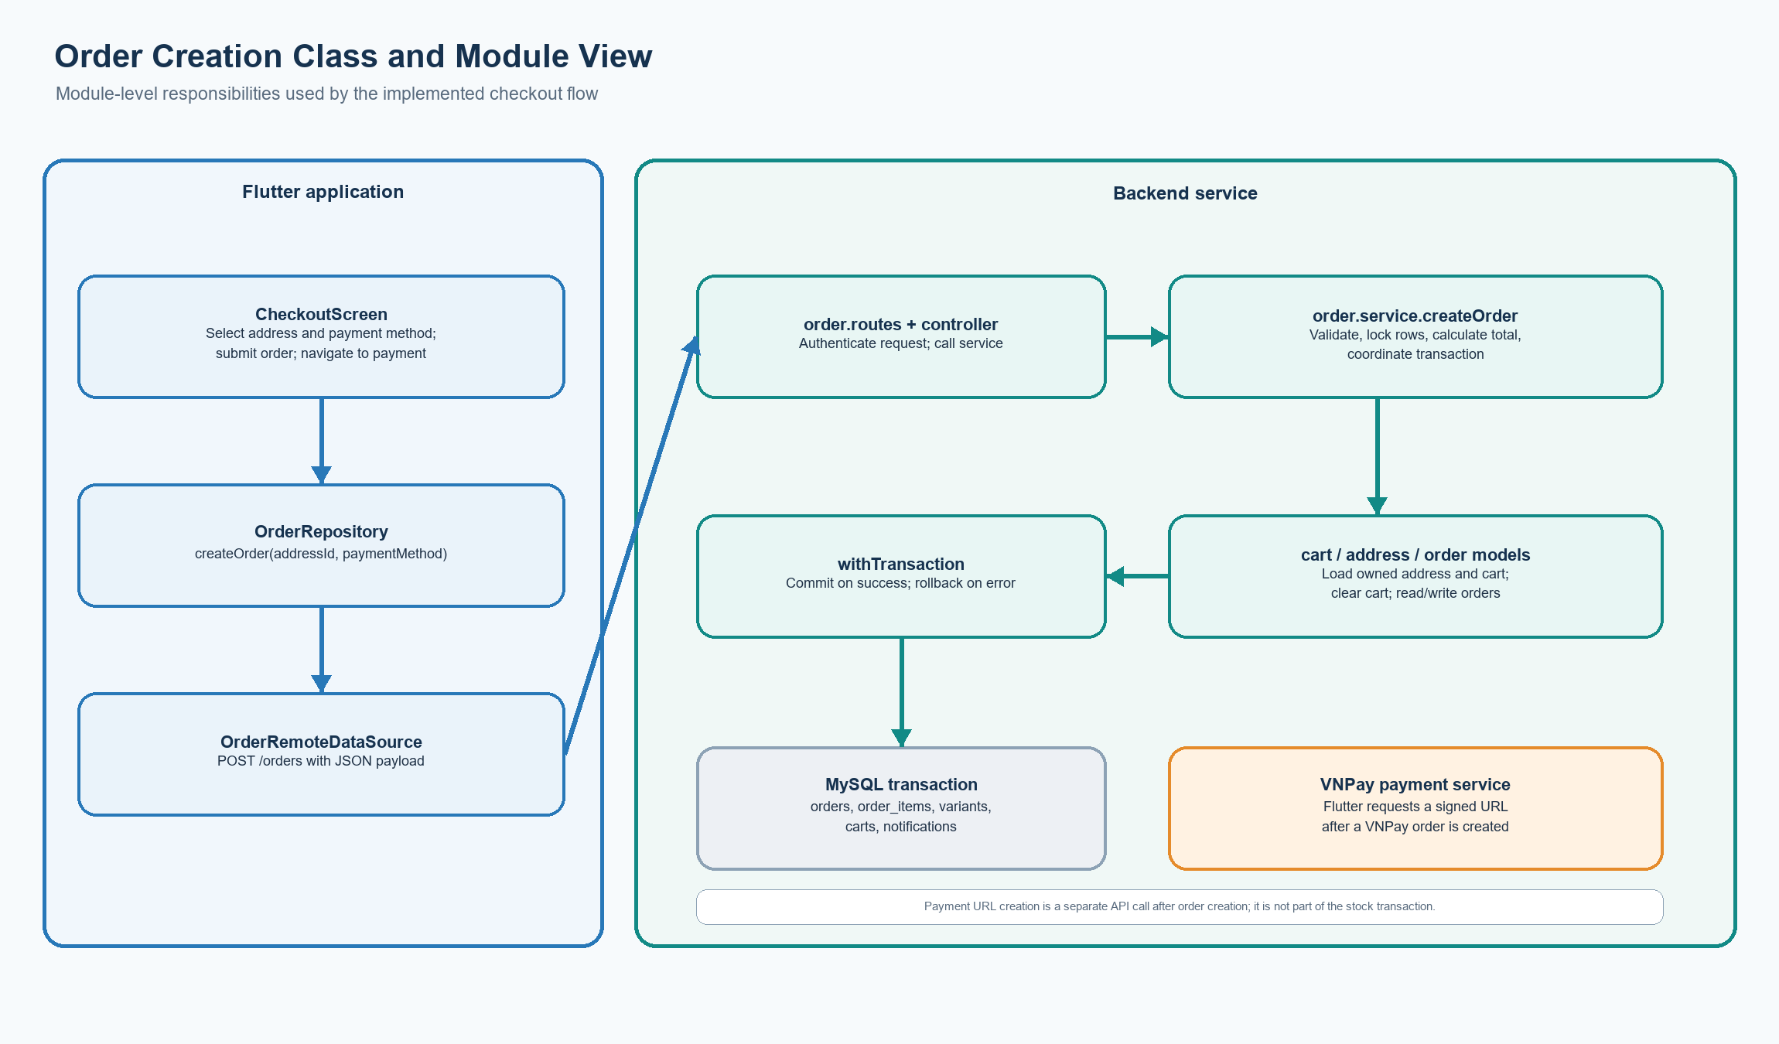
Figure 13. Order-creation module and class-style dependency view.
Module or class | Responsibility | Representative operation or data
CheckoutScreen | Collect address and payment choice; display validation and navigation state. | _placeOrder(); calls OrderRepository and PaymentRepository.
OrderRepository | Expose order operations to the Flutter presentation layer. | createOrder(addressId, paymentMethod), getOrder, cancelOrder.
OrderRemoteDataSource | Translate repository operations into HTTP requests and parse responses. | POST orders, GET orders/:id, PUT orders/:id/cancel.
order controller and routes | Authenticate and map HTTP requests to service calls. | create, list, detail, and cancel handlers.
order.service | Apply order rules, lock and validate data, coordinate writes. | createOrder(userId, input), cancelOrder(userId, id).
withTransaction | Commit successful work or roll back on an exception. | Runs a callback with a MySQL connection.
cart, address, order models | Read or write cart, owned address, and order records. | Cart locking/clear; address ownership; order history and detail.
payment.service | Create and settle VNPay attempts separately from order creation. | createVnpayPayment, inspectVnpayReturn, processVnpayIpn.

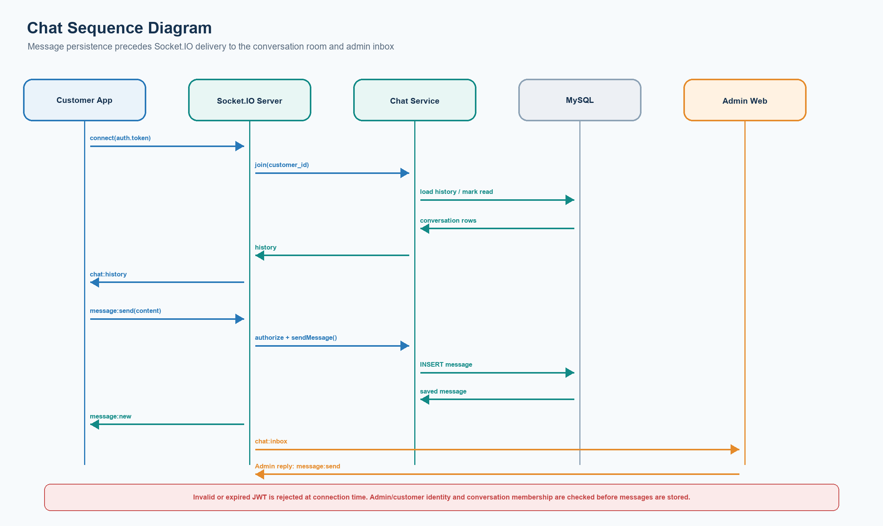
Figure 14. JWT-authenticated customer/admin chat sequence.
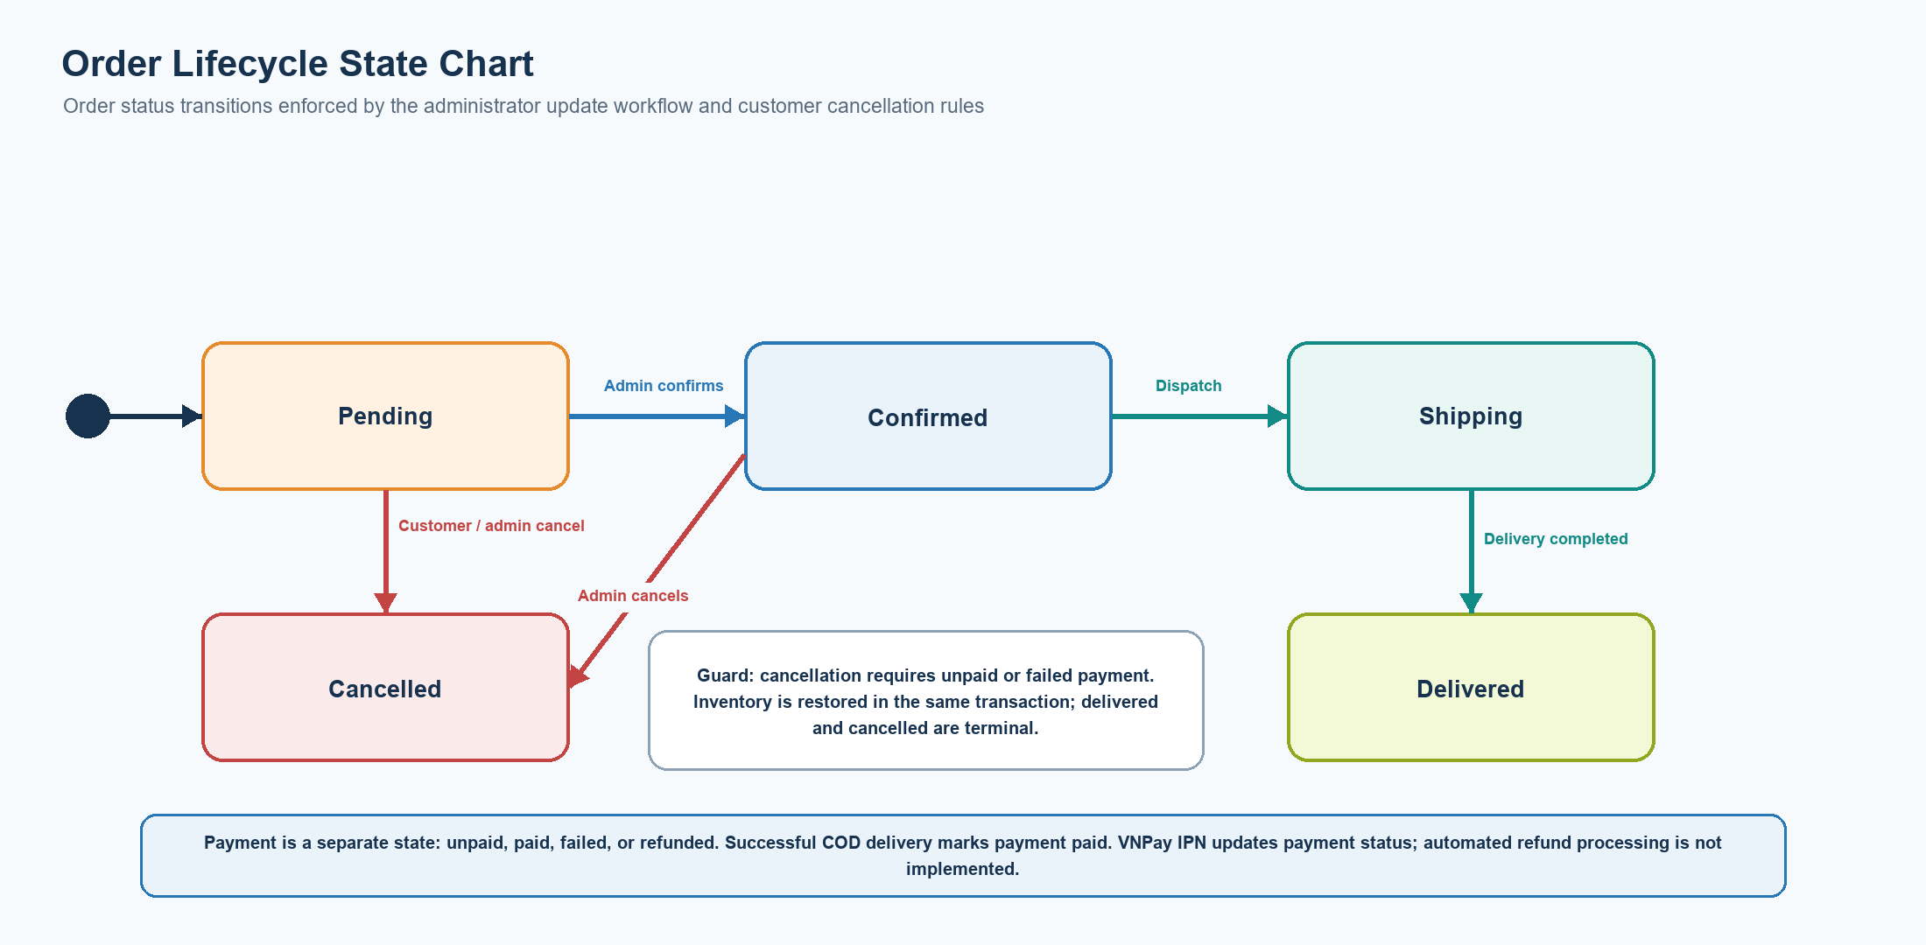
Figure 15. Order status state chart and cancellation guards.
Design approach | Where it appears | Purpose and limitation
Layered architecture | Backend routes/controllers/services/models; Flutter presentation/providers/data. | Separates transport, business rules, persistence, and UI responsibilities.
Repository pattern | Flutter data/repositories. | Provides application-facing operations over remote data sources.
Provider state management | Flutter ChangeNotifier providers. | Shares authentication, catalog, cart, wishlist, chat, and notification state.
Dependency injection by composition | Flutter main.dart and constructors. | Wires clients, data sources, repositories, and providers at startup.
Transaction script | Backend services with withTransaction. | Coordinates related SQL statements atomically for checkout, cancellation, and admin status changes.

The design additions are based on the current source structure and database schema. Numeric performance objectives, production hosting topology, automated payment refunds, and unpaid-order cleanup remain outside the implemented and verified scope.

